Biography
Dr. Joey Wing-yan Chan is an Associate Professor (Clinical) in the Department of Psychiatry at The Chinese University of Hong Kong. She received her MBChB from CUHK in 2006 and obtained the qualification of specialist in psychiatry in 2013. Her research focuses on sleep and circadian rhythms and their roles in neuropsychiatric disorders. Dr. Chan has publications in the field of insomnia, circadian disturbances and their links with affective disorders and neurodegeneration, and has made notable contributions to circadian-focused interventions. She serves as principal investigator for multiple randomized controlled trials of non‑pharmacological chronotherapeutic treatments. In recognition of her clinical and academic achievements, she received the Distinguished Young Fellow Award from the Hong Kong Academy of Medicine in 2022. Dr. Chan is President of the Hong Kong Society of Sleep Medicine and serves on international and regional sleep and chronobiology committees.

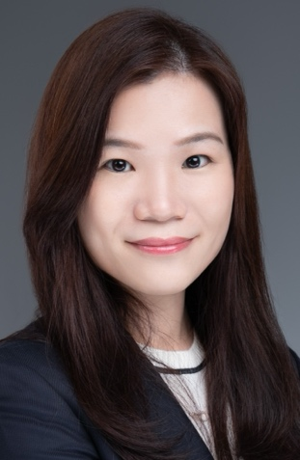
陳詠欣醫生（Dr. Joey Wing-yan Chan）現為香港中文大學醫學院精神科學系臨床副教授。她於2006年獲得香港中文大學內外全科醫學士（MBChB）學位，並於2013年取得精神科專科醫生資格。陳醫生的研究重點為睡眠與晝夜節律，以及其在神經精神疾患中的角色。她在失眠、晝夜節律失調及其與情感性疾病和神經退化之關聯等領域發表了多項研究成果，並對以晝夜節律為核心的介入治療作出了顯著貢獻。她亦擔任多項非藥物時間治療隨機對照試驗的首席研究員。為表彰其臨床與學術成就，陳醫生於2022年獲香港醫學專科學院頒授「傑出青年院士獎」。此外，她現任香港睡眠醫學會會長，並參與多個國際及區域性的睡眠與時間生物學相關委員會。

